WEEK-9- Implementation of Elastic Load Balancer with Auto Scaling using AWS EC2 Instances.
Elastic Load Balancer (ALB)
STEPS:
- Launch Two EC2 Instances
- Create a Load Balancer
- Verify Load Balancer
- Optional – Test Health Checks

Step 1: Launch Two EC2 Instances
1.1 Launch EC2 Instance #1
- Go to AWS EC2 Console → Launch Instance.
- Name: webserver-1
- Choose an AMI (Amazon Linux 2).
- Select Instance Type (e.g., t2.micro).
- Add Storage (default is fine).
- Configure Security Group:
  - Allow SSH (22) from your IP
  - Allow HTTP (80) from anywhere (0.0.0.0/0)
- Launch → Select/Create Key Pair → Launch.
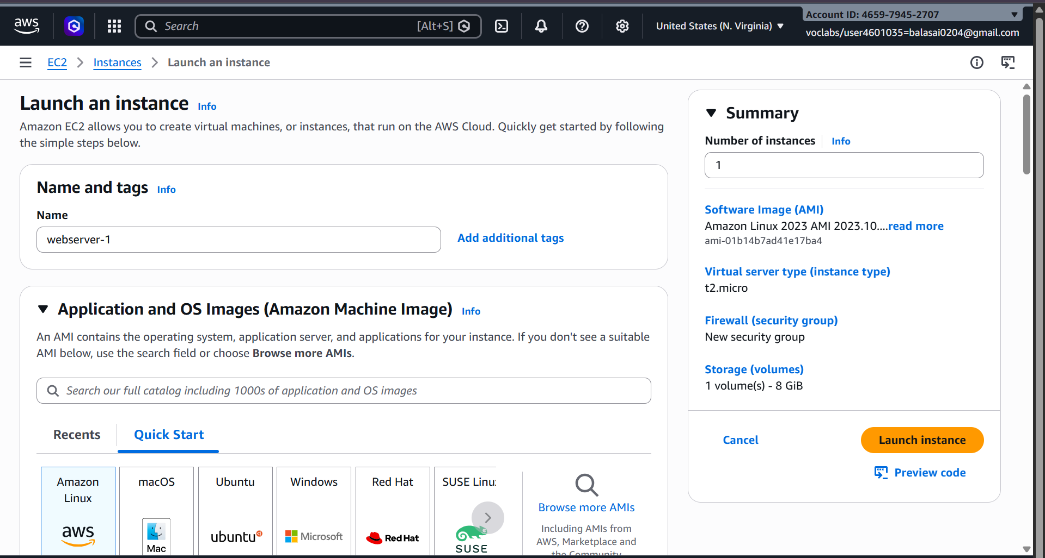
Run these commands after connecting VM
Sudo su //move to root user
yum update -y //Updates all installed packages to the latest versions
yum install httpd -y //installs the Apache HTTP Server on your EC2 instance.
systemctl start httpd //starts the Apache web server on your EC2 instance.
systemctl enable httpd //ensures that the Apache web server starts automatically whenever the system (EC2 instance) reboots.
echo "This is Server 1" > /var/www/html/index.html //It creates or replaces the homepage with given msg
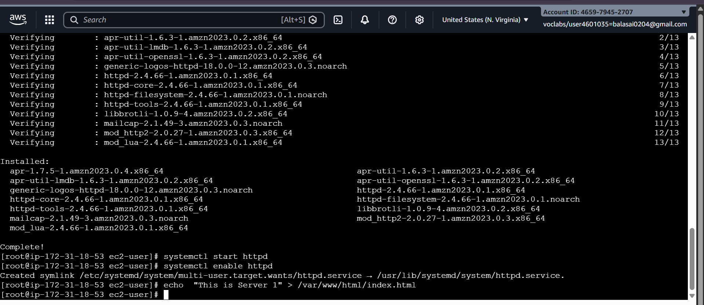

✅ Now you create second EC2 instances running Apache, with message This is Servier 2 each serving a simple web page.
Repeat it for second instance
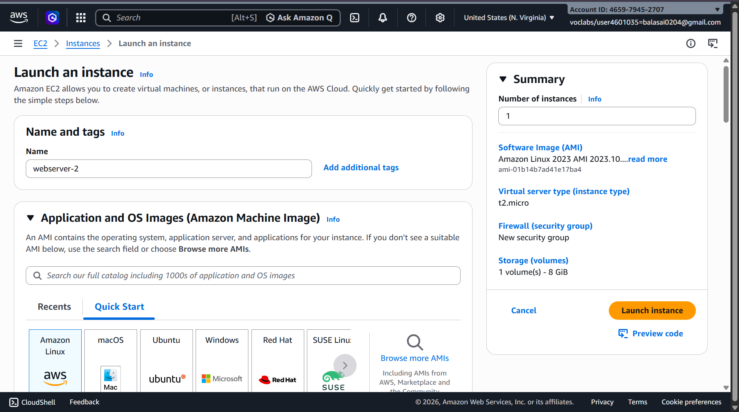
Sudo su //to move to root user
yum update -y //Updates all installed packages to the latest versions
yum install httpd -y //installs the Apache HTTP Server on your EC2 instance.
systemctl start httpd //starts the Apache web server on your EC2 instance.
systemctl enable httpd //ensures that the Apache web server starts automatically whenever the system (EC2 instance) reboots.
echo "This is Server 2" > /var/www/html/index.html //It creates or replaces the homepage with given msg

Step 2: Create a Load Balancer
AWS provides Elastic Load Balancer (ELB). We will create an Application Load Balancer (ALB).

2.1 Configure Security Group for Load Balancer
- Go to EC2 → Security Groups → Create Security Group
  - Name: lb-sg
  - Allow HTTP (80) from anywhere
  - Optional: HTTPS (443) if using SSL
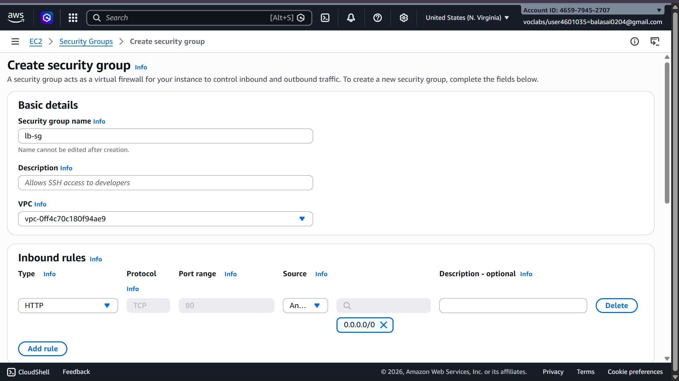

2.2 Create the Load Balancer
- Go to EC2 → Load Balancers → Create Load Balancer → Application Load Balancer
- Basic Configuration:
  - Name: my-alb
  - Scheme: Internet-facing
  - IP address type: IPv4
- Listeners:
  - Default: HTTP (80)

2.3 Configure Availability Zones
- Select the deafault VPC where your EC2 instances exist
- Select two /all subnets (one for each instance if possible)

2.4 Configure Security Groups
- Choose the lb-sg security group created earlier

2.5 Configure Target Groups
- Create a new target group:
  - Name: web-servers-tg
  - Target type: Instance
  - Protocol: HTTP
  - Port: 80
  - Health checks: / (default)
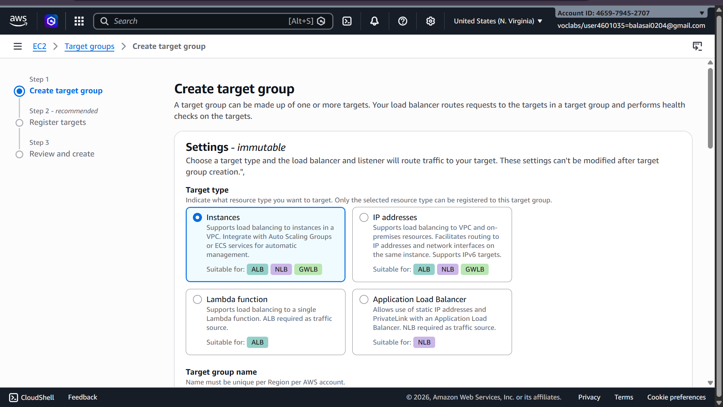
- Register Targets:
  - Select EC2 INSTANCES HERE --- webserver-1 and webserver-2
  - Click Include as pending → Register
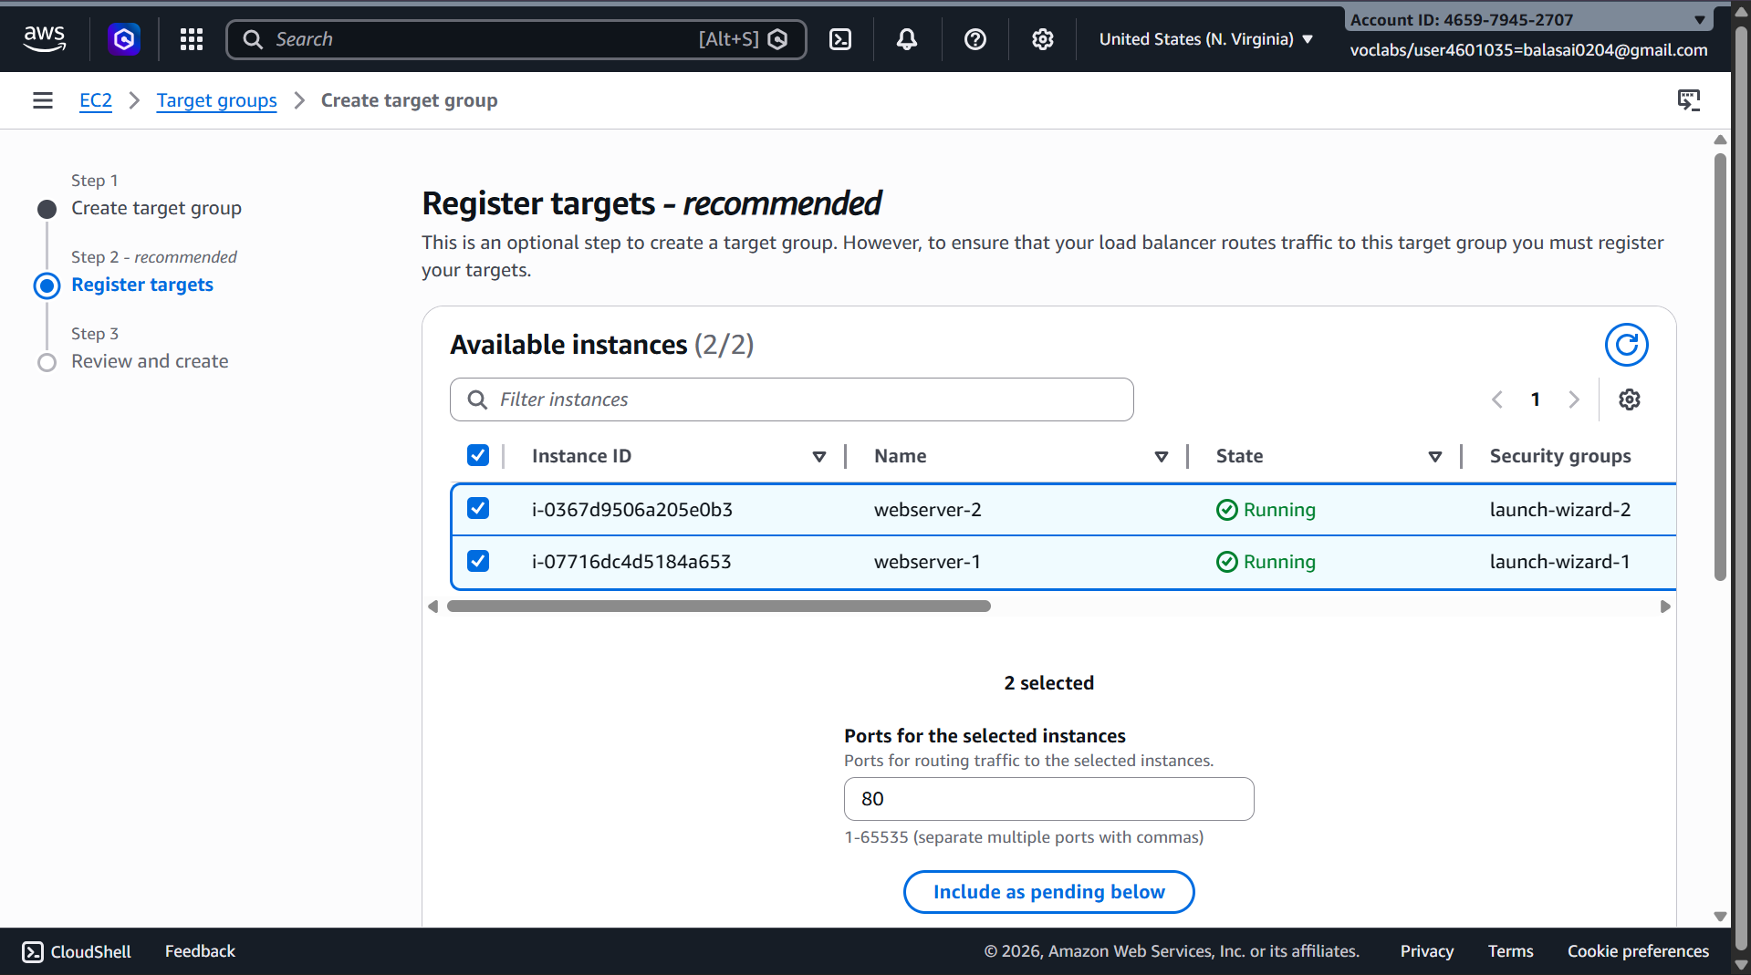

2.6 Review and Create
- Review all settings → Click Create Load Balancer
- AWS will take a few minutes to provision the ALB
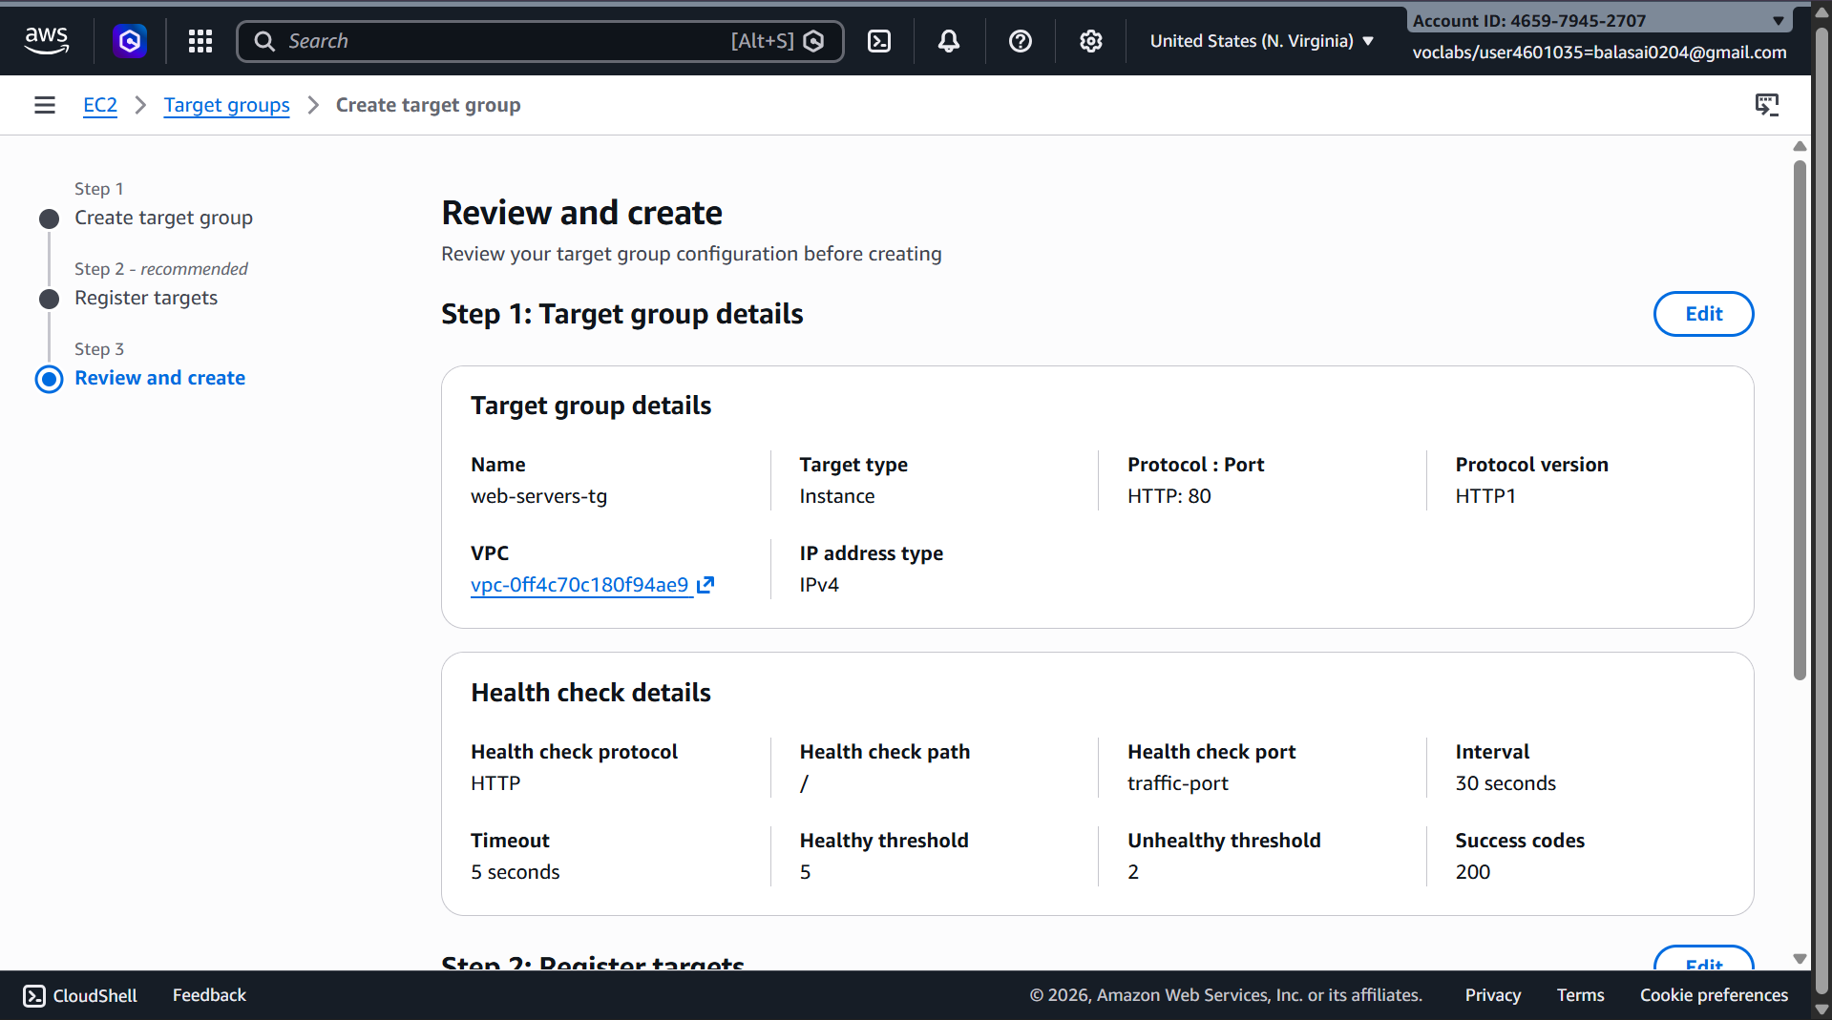
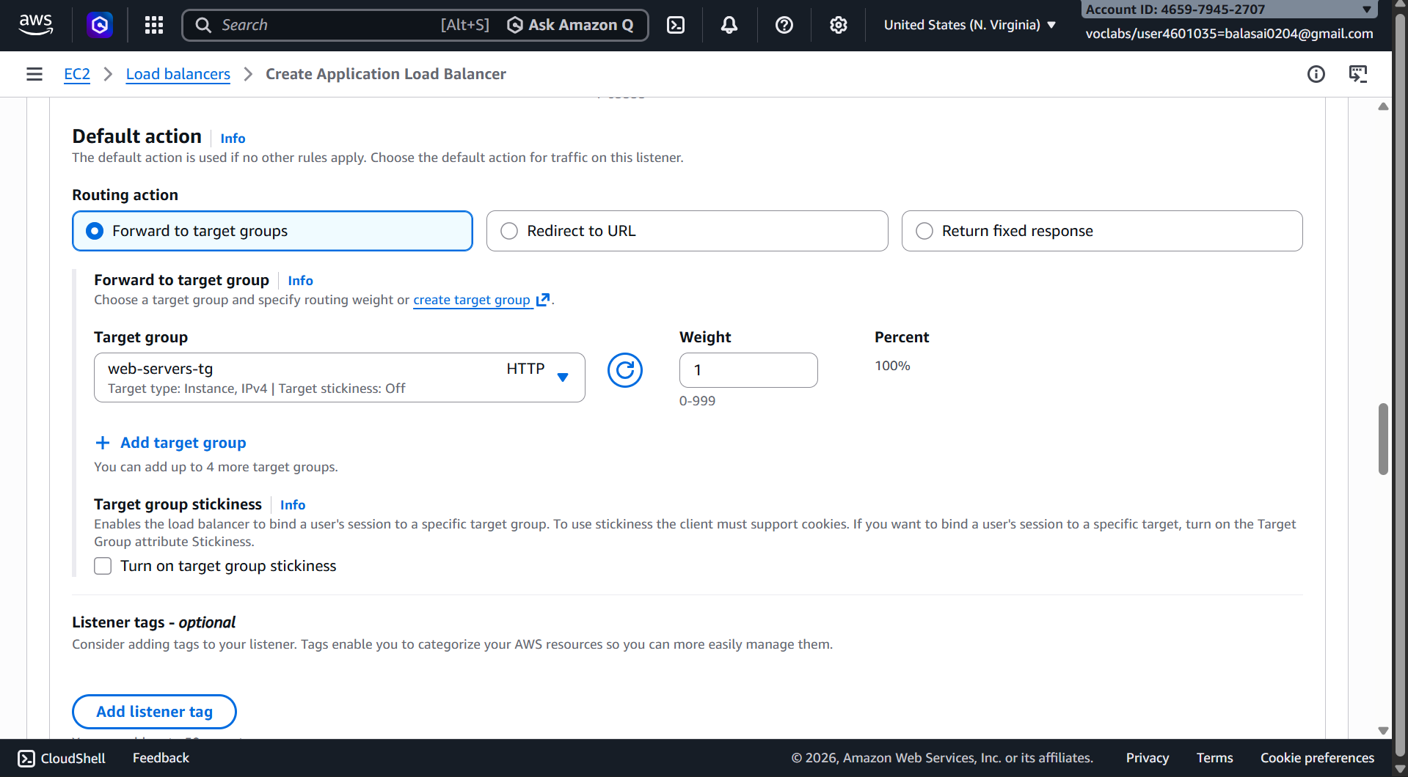

Step 3: Verify Load Balancer
- Go to Load Balancers → Select ALB → Description → DNS name
- Copy the DNS name (something like my-alb-123456.us-east-1.elb.amazonaws.com)
- Paste it in a browser → You should see either WebServer-1 or WebServer-2 page.
  - Refresh multiple times → Load balancer distributes traffic between the two instances
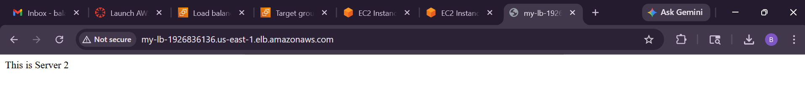
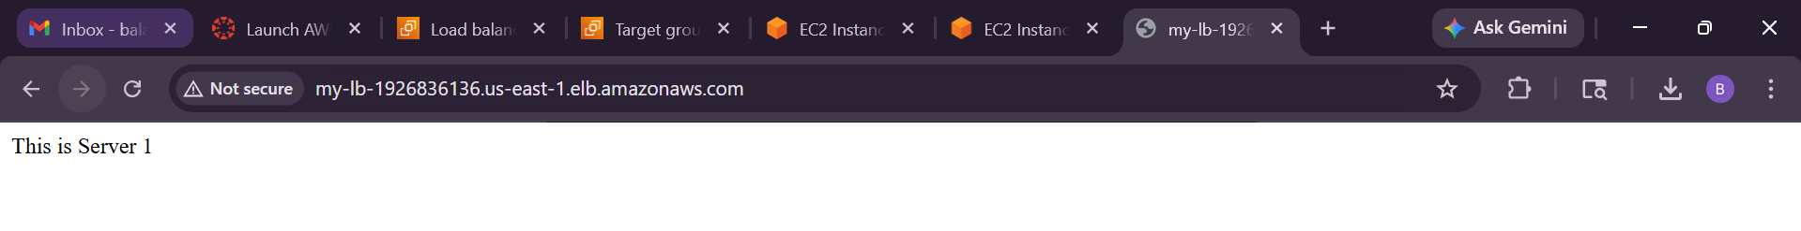

Step 4: Optional – Test Health Checks
- Go to Target Groups → web-servers-tg → Targets
- Ensure Status of both instances is healthy
If a server is unhealthy, check the bootstrapping script or security group rules.
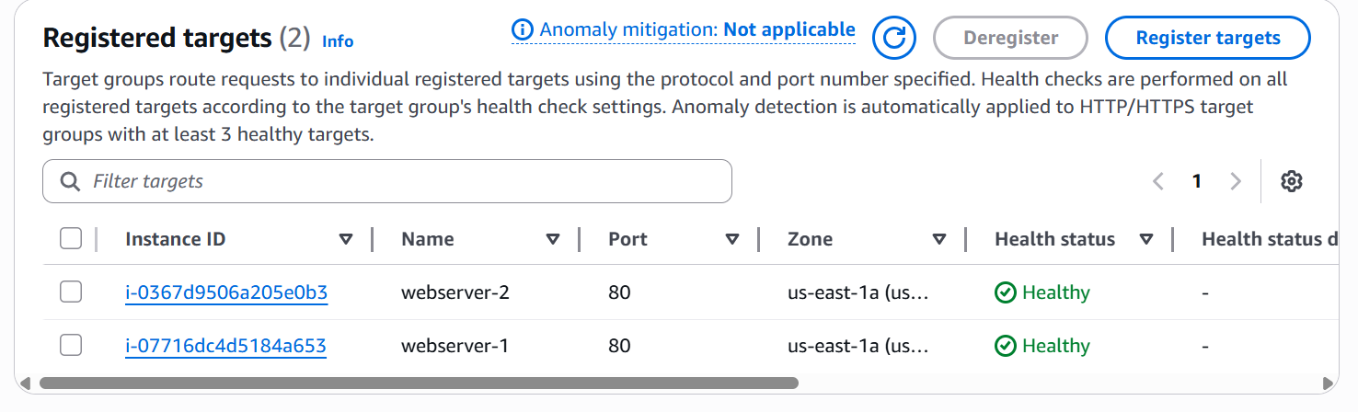

Step-by-Step: Auto Scaling Group with Load Balancer
- Create an AMI from Existing EC2 Instance
- Create a Launch Template
- Create Auto Scaling Group (ASG)
- Network Settings
- Configure Group Size
- Review and Create ASG
- Verify Load Balancer and Auto Scaling
- Test Load Balancer

Step 1: Create an AMI from Existing EC2 Instance
- Go to EC2 Console → Instances
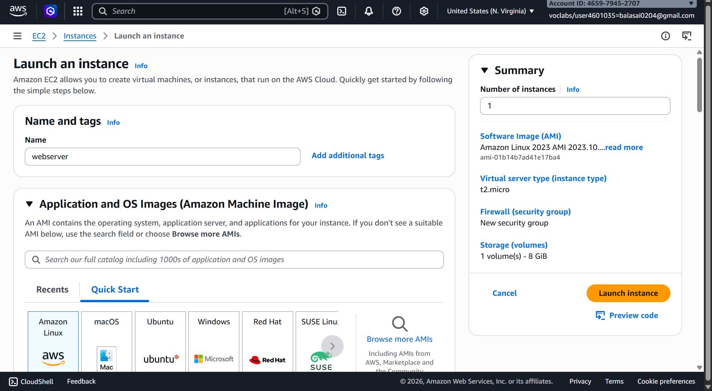
- Select the EC2 instance you already configured with bootstrapping
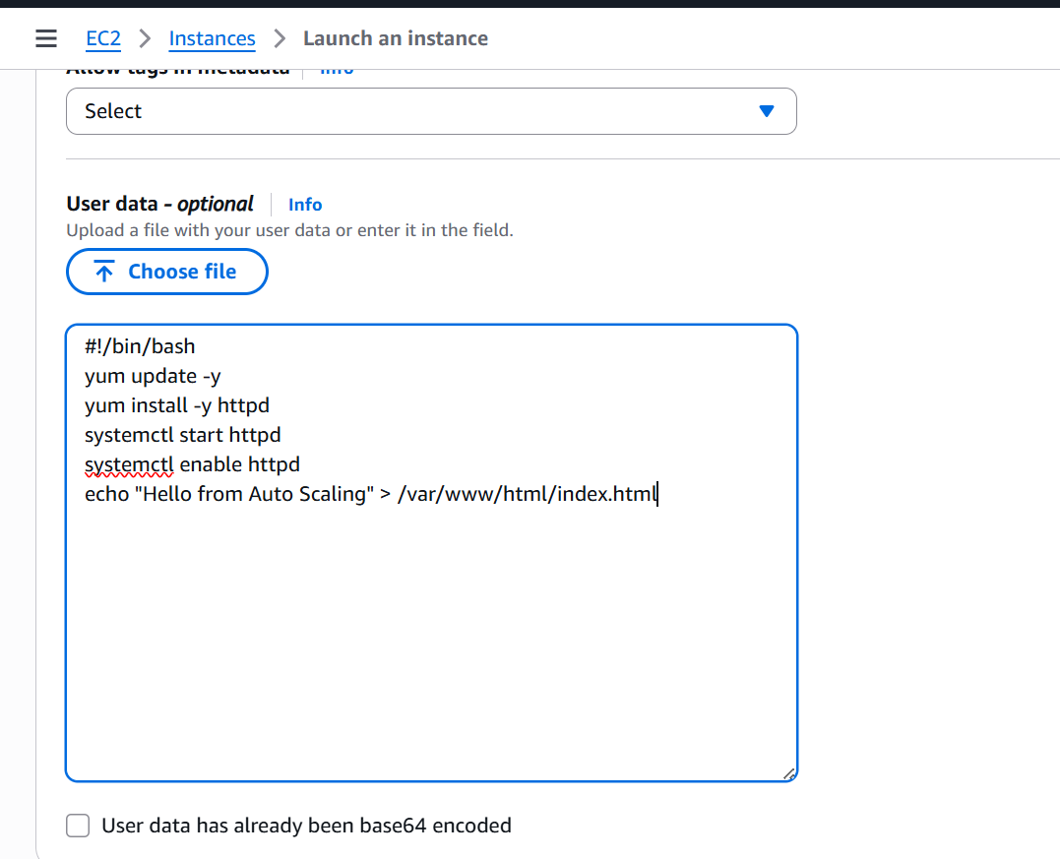
- Click Actions → Image and Templates → Create Image
- Provide Image Name: e.g., my-webserver-AMI
- Optional: Add description
- Click Create Image
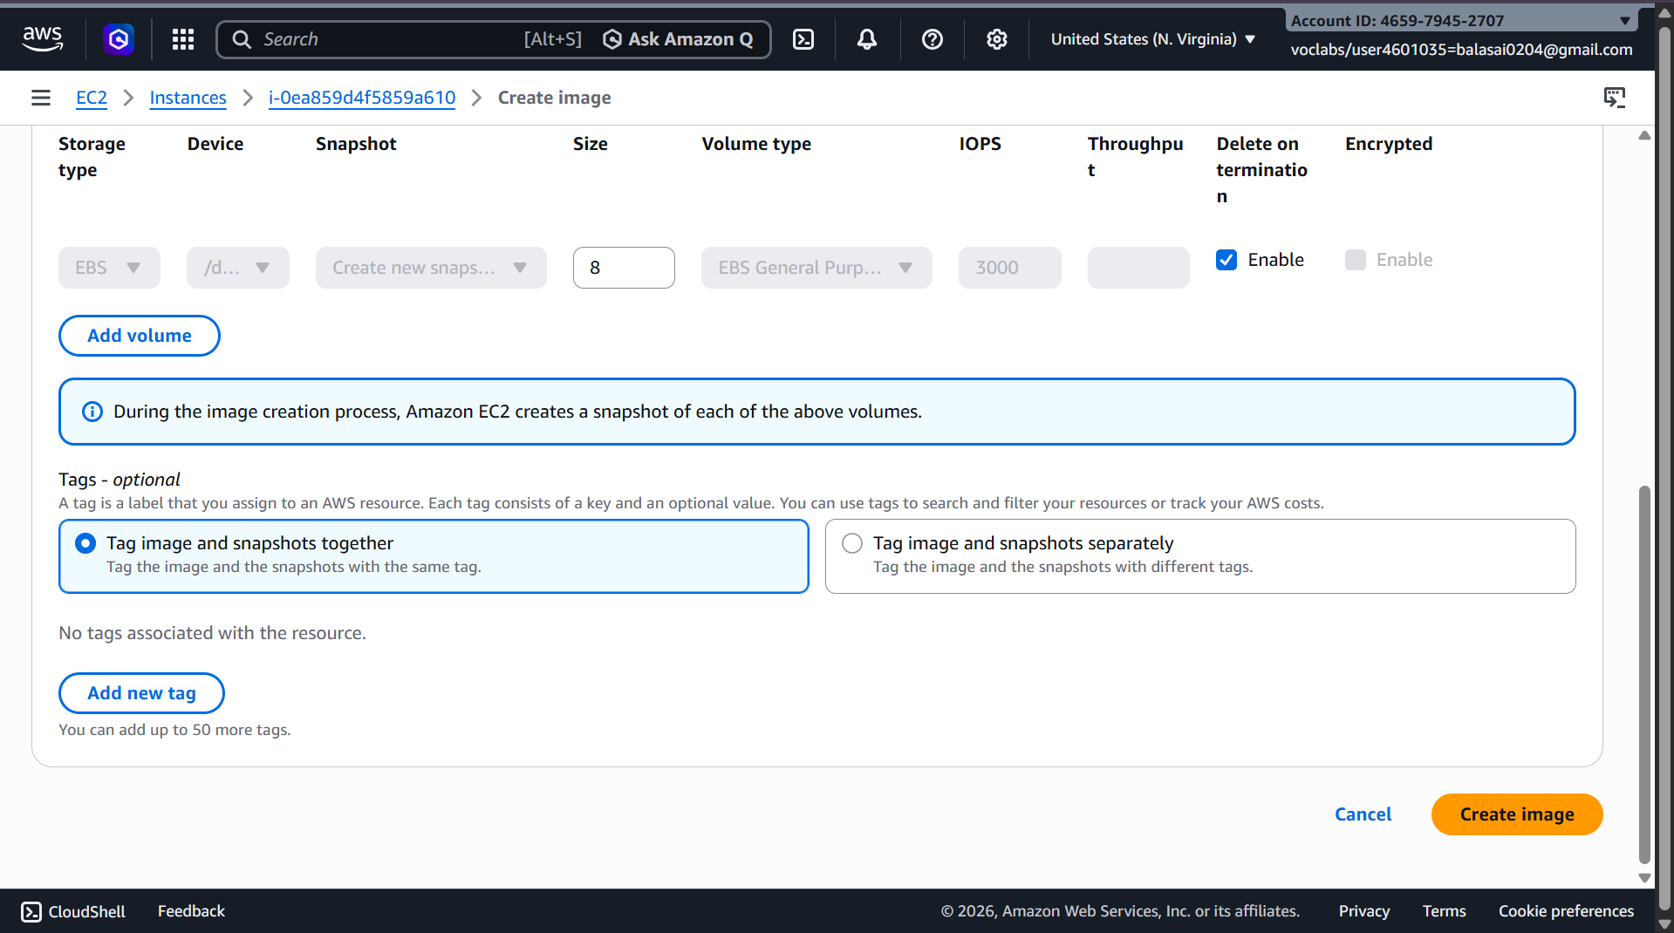
- Wait for the AMI to become available (status: available in AMIs sectio
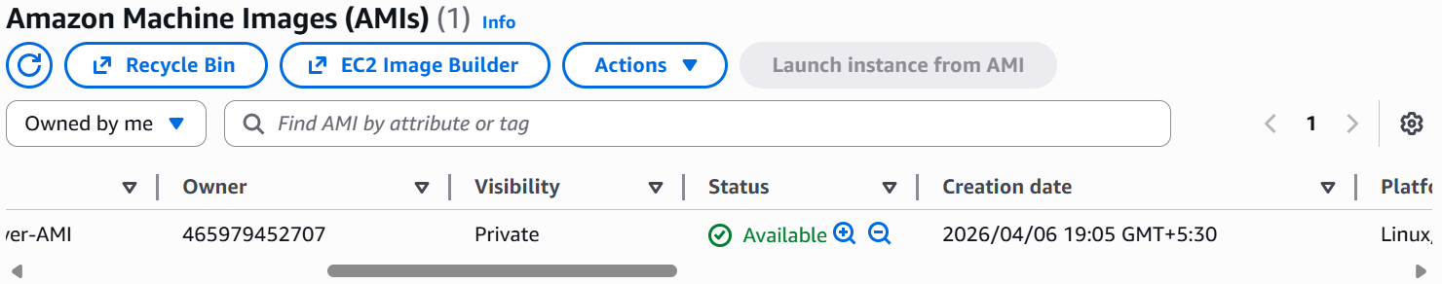
✅ This AMI will be used for launching new instances automatically in ASG.

Step 2: Create a Launch Template
- Go to EC2 → instances->Launch Templates → Create Launch Template
- Launch Template Name: my-launch-template
- AMI: Select the AMI created in Step 1 (my-webserver-AMI)
- Instance Type: t2.micro (or your choice)
- Key Pair: Select your existing key pair
- Security Groups: Select the Load Balancer Security Group (allow HTTP 80)
- User Data: Optional (already baked into AMI)
- Click Create Launch Template
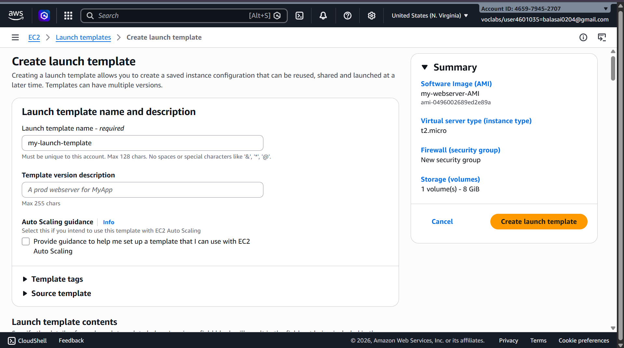
✅ Launch Template is ready for Auto Scaling.

Step 3: Create Auto Scaling Group (ASG)
- Go to EC2 → Auto Scaling Groups → Create Auto Scaling Group
- Name: webserver-asg
- Launch Template: Select my-launch-template
- Template Version: Select Version 1
- Click Next
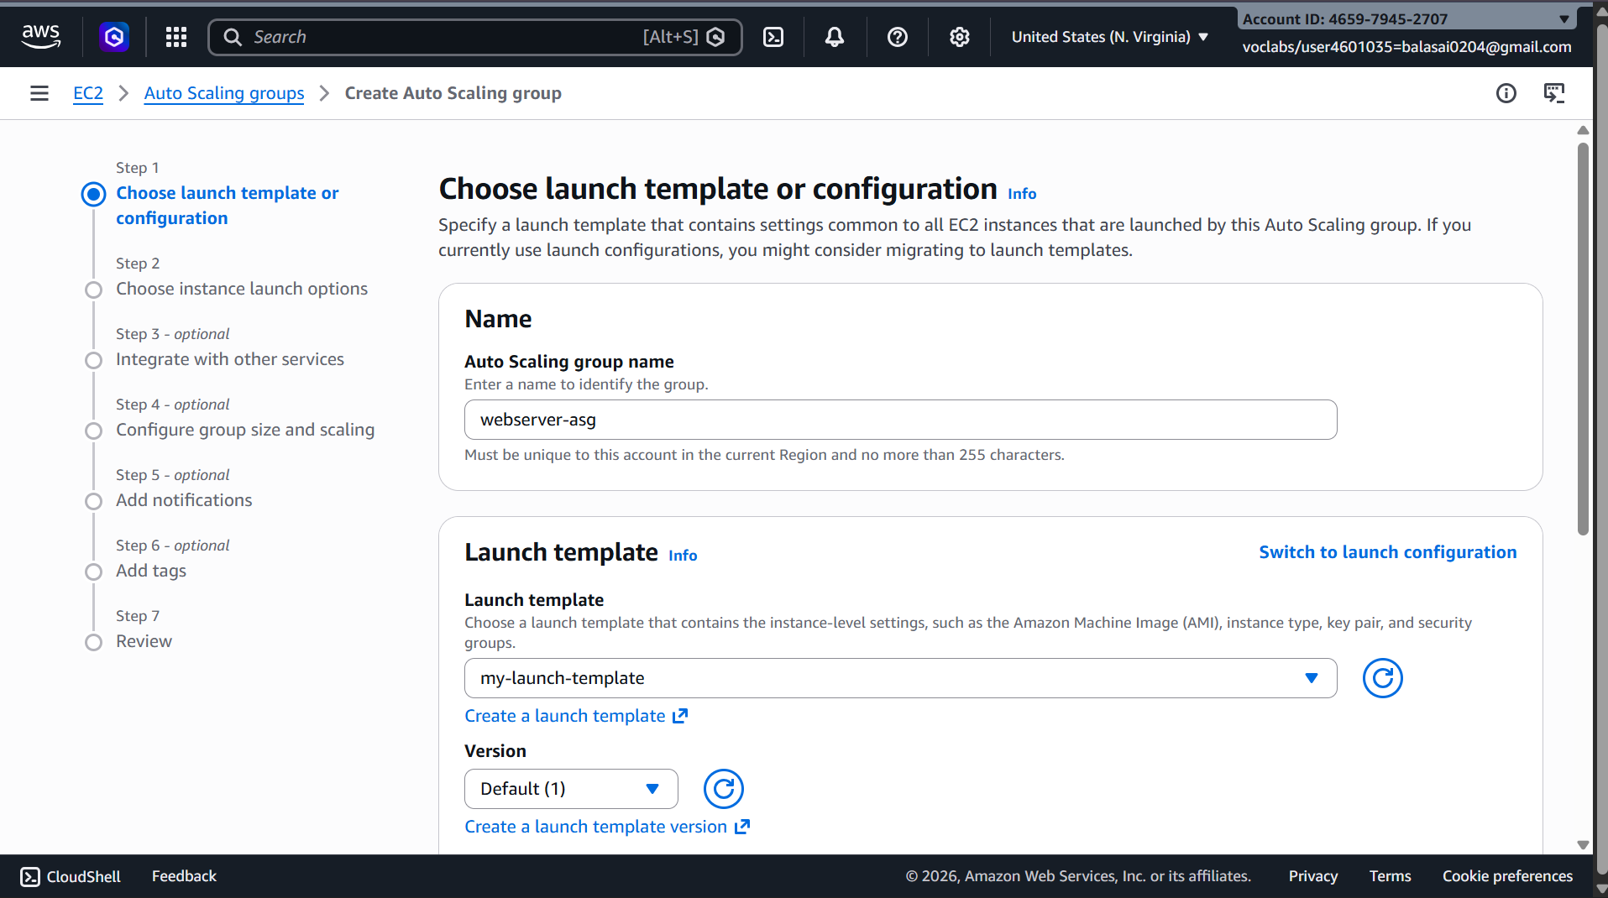

Step 3.1: Network Settings
- VPC: Default VPC (or your existing VPC)
- Availability Zones (AZs): Select all subnets (for high availability)
- Load Balancer: Enable Attach to an existing load balancer
  - Select your existing Load Balancer
- Health Check: HTTP
  - Set Health Check Grace Period: 300 seconds
- Click Next
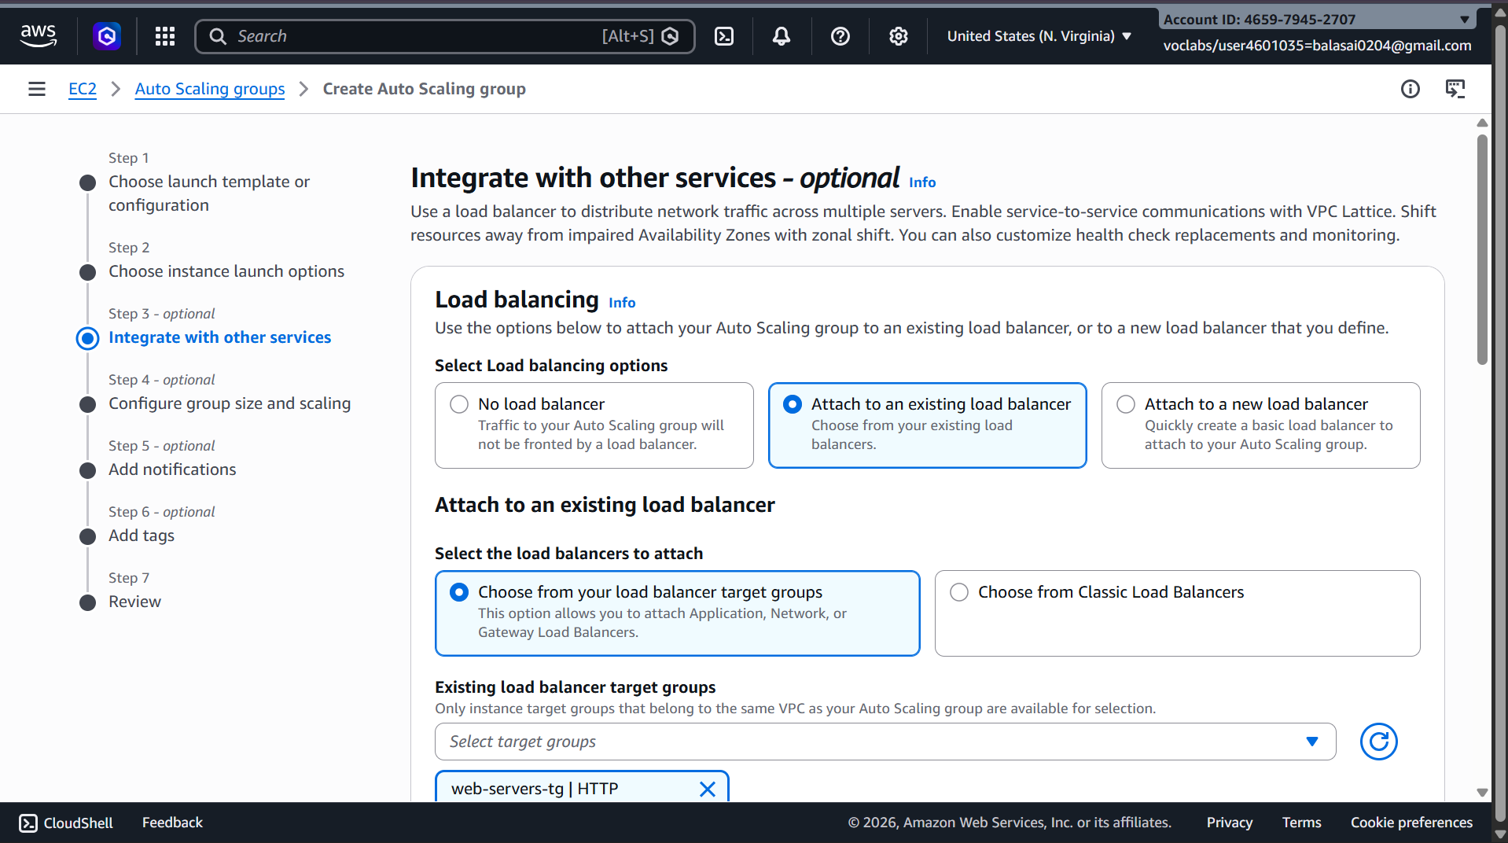

Step 3.2: Configure Group Size
- Desired Capacity: 2 (initial instances)
- Minimum Capacity: 1
- Maximum Capacity: 4
- Click Next
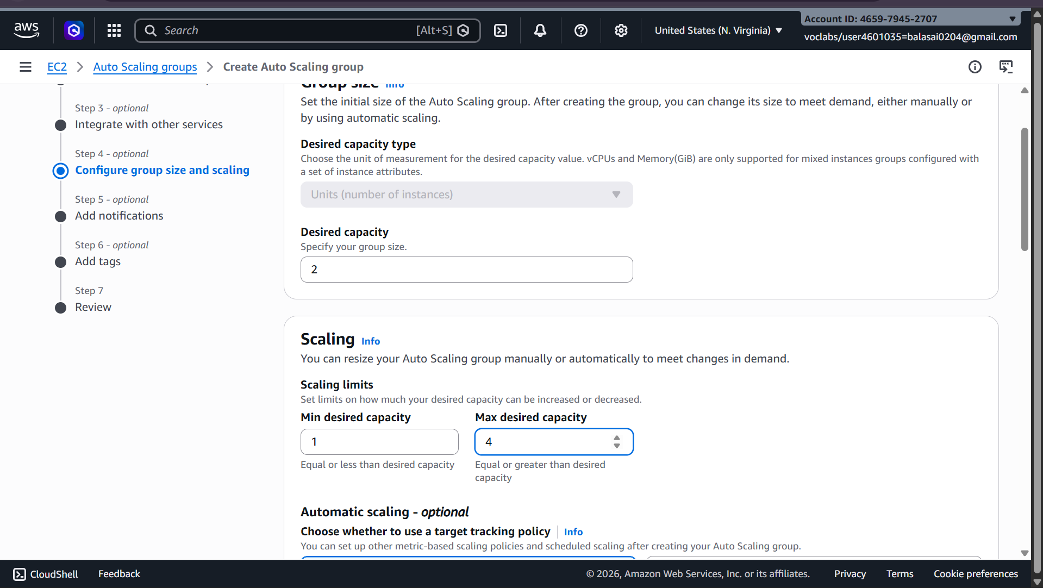

Step 3.3: Review and Create ASG
- Review all settings
- Click Create Auto Scaling Group
✅ Auto Scaling Group is now ready and attached to your Load Balancer.
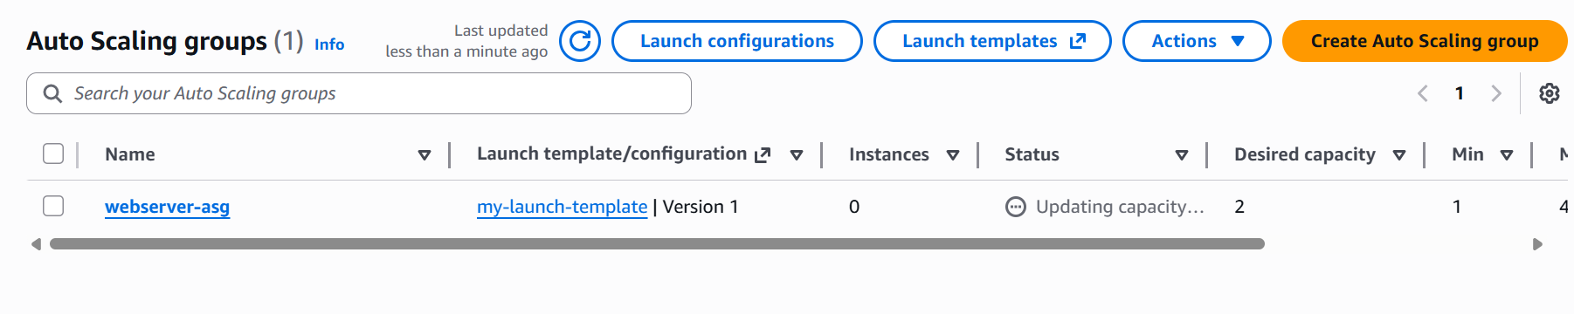

Step 4: Verify Load Balancer and Auto Scaling
- Go to Load Balancers → Select your Load Balancer
- Click Instances → Target Group → Registered Targets
  - You will see 2 healthy instances initially
- Check Auto Scaling Group → Instances
  - You may see up to 4 instances if scaling triggers
- Test auto recovery:
  - Terminate one of the instances
  - After a few seconds, ASG will launch a new instance automatically
  - Traffic will automatically be distributed by the Load Balancer
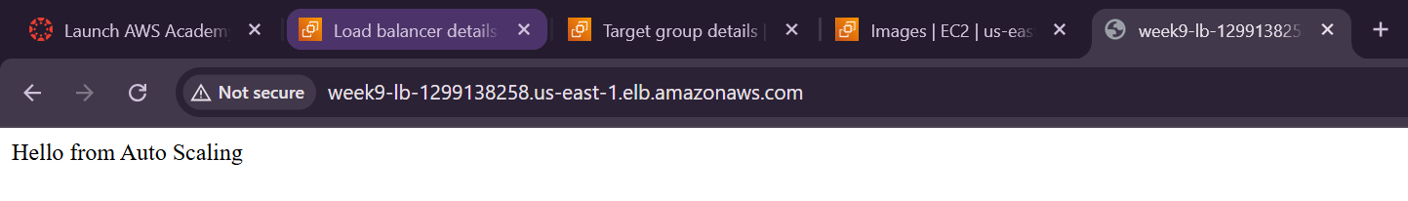

Step 5: Test the Load Balancer
- Copy the Load Balancer DNS Name from ALB
- Open in a browser → You should see your web page from one of the instances
- Refresh multiple times → traffic alternates between instances
✅ This confirms Auto Scaling + Load Balancer is working correctly.

Summary of Flow
- Create AMI → snapshot of working EC2
- Create Launch Template → using AMI, security group
- Create Auto Scaling Group → attach Launch Template, set min/desired/max, attach Load Balancer
- Verify instances → ASG launches/replaces instances automatically
- Test Load Balancer → distributes traffic between all active instances

Scenario Based Questions (ELB & Auto Scaling)
1. A company has 2 EC2 instances but one gets overloaded. Which service distributes traffic evenly?
Answer: Use Elastic Load Balancer. It distributes incoming traffic evenly across multiple EC2 instances.

2. Multiple EC2 instances but want single entry point instead of multiple IPs. Which service?
Answer: Use Elastic Load Balancer. It provides a single DNS endpoint for users.

3. Servers overloaded at peak, idle at non-peak. Which feature helps?
Answer: Use Auto Scaling. It automatically increases or decreases instances based on demand.

4. Load balancer sending traffic to unhealthy server. Which feature helps?
Answer: Health Checks in Elastic Load Balancer. It detects unhealthy instances and stops routing traffic to them.

5. Launch EC2 instances when CPU > 70%. What to use?
Answer: Configure Auto Scaling policy in Auto Scaling based on CPU utilization.

6. Application has global users, needs high availability. How ELB helps?
Answer: Elastic Load Balancer distributes traffic across multiple EC2 instances and availability zones, improving availability.

7. Auto Scaling not launching instances during high traffic. Why?
Answer: Missing or incorrect scaling policy, CloudWatch alarm, or wrong min/max capacity settings.

8. Maintain minimum 2 servers and scale when needed. What to define?
Answer: Set:
- Min = 2
- Desired = 2
- Max = higher value
in Auto Scaling

9. App crashes during traffic spikes. How ELB + Auto Scaling helps?
Answer: ELB distributes traffic, and Auto Scaling adds more instances during spikes, preventing overload and improving reliability.

10. ASG not attached to Load Balancer. What problem occurs?
Answer: Traffic won’t be distributed properly. Users may hit only one instance or cannot access new instances.

11. Replace unhealthy EC2 instances automatically. Which feature?
Answer: Auto Scaling health checks in Auto Scaling

12. Monitor EC2 performance and trigger scaling. Which service?
Answer: Use Amazon CloudWatch for metrics like CPU, network, etc.

13. Startup expects sudden traffic spikes. How Auto Scaling helps?
Answer: Auto Scaling automatically launches more instances during spikes and reduces them later.

14. Route requests based on HTTP/HTTPS. Which load balancer?
Answer: Use Application Load Balancer (ALB) under Elastic Load Balancer

15. Build highly available system with load balancing + scaling. Which services?
Answer: Combine:
- Elastic Load Balancer
- Auto Scaling
- Amazon EC2

